Jackson, Terrence. CMIS 141 7383. 11.5.2022.

|  | Input | Expected | Actual | Pass |
| --- | --- | --- | --- | --- |
| Test Case 1 | First num: 10 Second num: 500  Operation: + | Invalid number input: 10, 500 | Invalid number input: 10, 500 | yes |
| Test Case 2 | First num: 1000 Second num: 500  Operation: / | The result is: 2.0 | The result is: 2.0 | yes |
| Test Case 3 | First num: 500 Second num: 2  Operation: ^ | Invalid operation input: ^  Invalid number input: 500, 2 | Invalid operation input: ^  Invalid number input: 500, 2 | yes |
| Test Case 4 | First num: 500 Second num: 700  Operation: - | The result is: -200.0 | The result is: -200.0 | yes |
| Test Case 5 | First num: 800  Second num: 300  Operation: @ | Invalid operation input: @ | Invalid operation input: @ | yes |
| Test Case 6 | First num: 600 Second num: 1000  Operation: + | The result is: 1600.0 | The result is: 1600.0 | yes |
| Test Case 7 | First num: 200 Second num: 800  Operation: * | The result is: 160000.0 | The result is: 160000.0 | yes |

Test Case 1:

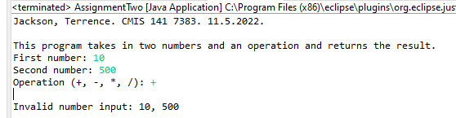

Test Case 2:

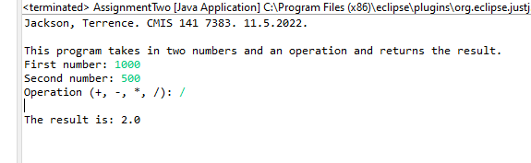

Test Case 3:

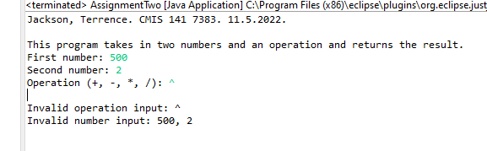

Test Case 4:

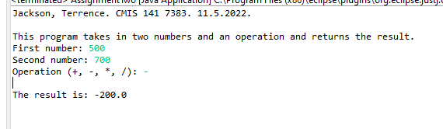

Test Case 5:

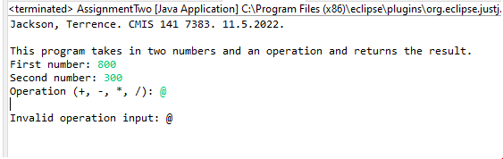

Test Case 6:

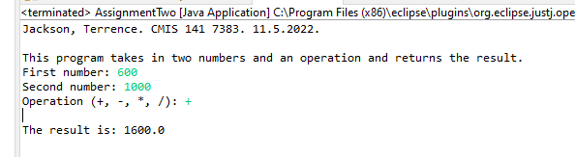

Test Case 7:

